Sports Day Application

Marc Jubb

Table of contents

Analysis 3

Introduction 3

Interview with the client, Mr Harrysson 3

Understanding the problem 4

Specification: Main Objectives 4

The current system 6

Design 9

High-level System View 9

Data Structures 9

Database Design 9

System and Data security 9

User interface design 9

Pseudocode of core algorithms 9

Design of core SQL statements 9

Technical Solution 10

Testing the Technical Solution 11

Introduction 11

Test Plan 12

Documented Testing 12

Evaluation 12

# Analysis

## Introduction

During my years at Ecclesbourne, we have had an event every year called “Sports Day”. This event includes many different activities and sport events in which students take part in to go against their peers to earn points for their house. These events are kept track of with an excel spreadsheet at the moment which includes the events names, students entered and other information needed for logistical use. This system has been recognised as insecure and tedious for the end user to operate. This is where Mr Harrysson is asking me to build a new system with additional features including security and easier to operate user interface. Decisively I have decided to take on the challenge.

## Interview with the client, Mr Harrysson

*“Why do you feel like the current sports day system is inadequate?”*

The issues are with the efficiency of inputting the data. Currently it is an inefficient use of a spreadsheet where you look through the large sheet of data looking for the right event before manually typing in the name. This causes human error with each input meaning we might miscalculate scores, pick the wrong student for an event and due barrier of skill required to use the spreadsheet we are required to train the staff to use the spreadsheet, which is causing resources and issues to arise. Last year was the day was vigorously interrupted with spreadsheet crashing with the amount of users accessing it.

*“Do you have an issue with security of the spreadsheet?”*

Yes, I do, with this spreadsheet, there are no entry requirements in order to make use of the spreadsheet or edit the results, which is a problem. Therefore, I would like very much a system in which you will need a username, which has an access level representing their user type and a password in order to proceed into the system. It would be fantastic if you were able to change the rights of the users depending on their level.

*“Are you able to print reports of the events out with ease?”*

No, currently I manually write out the results into the spreadsheet and if I were to print the results out them, I would use PrintScreen, which burns a lot of my time on the day to vanish. Therefor I would love an option to export the results into a different format, which makes printing able to do with ease.

*“What additional features would you like in the new program?”*

If possible, I would like to have graphics added, showing the data visually so the end user can compare results in a visual manner. There should be multiple graphs able to load which can be selected through a dropdown box. Also if possible, have the program allocate participants through a click and enter method. This has shown to reduce human error, as there is no typing needed. I want to be able to click on the student I want to allocate to an event and press enter to confirm him/her as a participant.

## Understanding the problem

The problem at hand with this system is that there is no feature of analytics built into it. Very inefficient in many aspects of the spreadsheet including assigning participants and searching through the students names in order to pinpoint the student that is wanted to be edited, deleted or added.

Another issue is that whoever has access to the excel spreadsheet can freely edit the data which causes a risk of cheating and other serious issues to occur. Therefore, there will need to be a new login system with users to be able to have different access rights so that certain users may not be able to allocate scores.

Using my project I wish to develop an incredibly more user friendly design with the aspect of student, administrators and house captains all having user-adapted menu’s and selections.

The project will also have a database connected, efficiently storing the data in access. This enables me to use cross-tabular parameterized SQL queries prevailing my advance skill manipulating a database with SQL.

Using decomposition, I break down the project into smaller parts In order to analyse each step I will need to go through in my coding.

## Specification: Main Objectives

* Login System with access rights depending on their username’s access level.
* Create an account system connected to a database.
* Main menu which options change upon the user’s rights for security of the results
* Student form with a list displaying all of the student’s data including name, house, year group, age group and gender. With the ability to edit, remove and insert the student’s data.
* Event form with a list displaying all of the events information including event name, age group for that event, gender and event type. With the ability to edit, remove and insert the events data.
* An allocation form where you can select an event from the list of events, then choose the students you wish to allocate to that event and press a button to allocate them. The display should have two tables one with all the students in that age group and gender and the other should have the participants in the event. When you allocate one student, it should automatically update both tables with the data entered.
* The allocation form should also have an option to export the participants table into to another format in order to print tickets and reports for the students to understand who is in each event.
* There should be another option in the main menu for administrators only to allocate the scores of the participants into a table and when a confirmation button is hit then the program will store the results into database. You should be able to input the data directly into a table, the scores of each participant should be automatically calculated and displayed with the winner at the top and the loser at the bottom.
* For security, reasons only the administrators will have the option in the menu to create an account for another admin. This should display in the main menu of the project and the end user will enter an access level for the new user, a password and a username.
* For all users a leader board in order to show the current state of the sports day. This will have five tables. One showing the houses positions and point’s relative. The other four showing the MVP for each gender and age group.
* My project should have a form with graphs displaying the visual image of each house showing the points of each house, one for each age group and gender.

## Specification: Detailed objectives

1. Login Form
   1. Title: The Ecclesbourne School, Sports Day
   2. Textbox allowing user to enter their username
   3. Textbox allowing user to enter their password
   4. Button allowing the user to login
      1. Proceed to Main Menu if username and password Correct
   5. Button allowing the user to register
      1. Proceed to Register Form
2. Register Form
   1. Textbox allowing user to enter their new username
   2. Textbox allowing user to enter their new password
   3. Button allowing the user to Register
      1. If username is not taken, register user
      2. If username is taken, show message with “Username Taken”
3. Main Menu Form
   1. Access Level Student
      1. Button proceeding to Graphing Data Form
      2. Button proceeding to the Leader board form
      3. Button proceeding to Attempts and Results Form
         1. Cannot edit or add results.
   2. Access Level House Captain (Has the access level of Student)
      1. Button proceeding to Student Form
      2. Button proceeding to Event Form
      3. Button proceeding to Allocation of Participants Form
   3. Access Level Administrator (Has the access level of House Captain)
      1. Button proceeding to Create an Admin Form
      2. Can edit or add results of Attempts and Results form
4. Manage Students Form
   1. Table with all the student’s data shown
      1. First Name
      2. Surname
      3. Year group
      4. Age Group
      5. Gender
      6. House
   2. Search system for the table
      1. Textbox for first name search
      2. Textbox for second name search
      3. Combo box for Gender, Year group, Age group and house
   3. Button to add a student
      1. Proceeds to Addstudent Form
      2. In the add student form I would like there to be an input box for forename and surname but for the other options it would be optimal to use a combo box to select gender, school year, age group and house. Then after a button is pressed the information added to the boxes is inserted respectively into the database.
   4. Button to remove a student
      1. The highlighted student will be removed from the database and all instances of that user will be deleted.
   5. Button to update a student’s data
      1. The highlighted student in the table will have their information displayed through textboxes and combo boxes. The user will be able to edit and update the information freely and when the update button is pressed their information will be updated I the database concurrently.
5. Add Student Form
   1. Textbox – Forename
   2. TextBox - Surname
   3. Combobox – Gender
   4. Combobox – Age Group
   5. Combobox – School Year
   6. Combobox – House
   7. Button to add the information inputted by user into the database
6. Update Event Form
   1. Button- Next Student (To navigate through students)
   2. Button- Last Student
   3. Textbox – Forename
   4. TextBox - Surname
   5. Combobox – Gender
   6. Combobox – Age Group
   7. Combobox – School Year
   8. Combobox – House
   9. Button to update the edited data by user into the database
7. Manage Events Form
   1. Table with all the event’s data
      1. Event Name
      2. Age Group
      3. Gender
      4. Event Type
   2. Search system for the table
      1. Textbox for Event name search
      2. Combo box for Gender, Age group and Type of event
   3. Exporting Button’s to report the events
      1. HTML Export
      2. Excel Export
   4. Button to add event
      1. Proceeds to Add Event form
   5. Button to update Event
      1. Proceeds to Update Event Form
   6. Button to remove Event
      1. The selected event by the user when this button is pressed will be removed
8. Add Event Form
   1. Textbox – Event Name
   2. Combobox – Gender
   3. Combobox – Age Group
   4. Combobox – Type of event
   5. Button to add the information inputted by user into the database
9. Update Event Form
   1. Textbox – Event Name
   2. Combobox – Gender
   3. Combobox – Age Group
   4. Combobox – Type of event
   5. Button to update the information inputted by user into the database
10. Event Allocation Form
    1. Table with all the event’s data
       1. Event Name
       2. Age Group
       3. Gender
       4. Event Type
    2. Search system for the table
       1. Textbox for Event name search
       2. Combo box for Gender, Age group and Type of event
    3. Label directing the user to double click an event they want to allocate participants to
       1. Proceeds user to a Participant Allocation form
11. Participant Allocation form
    1. Table with the student’s that are able to partake into the event selected previously
       1. First Name
       2. Surname
       3. Year group
       4. Age Group
       5. Gender
       6. House
    2. Search system for the table
       1. Textbox for first name search
       2. Textbox for second name search
       3. Combo box for Year group and house
    3. Table with all the Participants assigned to the event
       1. First Name
       2. Surname
       3. Year group
       4. Age Group
       5. Gender
       6. House
    4. Allocate to event button
       1. Takes the highlighted student in the Student table and allocates him to the event, moving him to the participant table automatically.
    5. Export Buttons – Reporting of event
       1. HTML
       2. Excel
    6. Remove Participant
       1. Takes the highlighted student in the Participant table and deallocates them, moving them to the student table automatically.
    7. Label that changes depending on the selected event
12. Event Results Select Form
    1. Table with all the event’s data
       1. Event Name
       2. Age Group
       3. Gender
       4. Event Type
    2. Search system for the table
       1. Textbox for Event name search
       2. Combo box for Gender, Age group and Type of event
    3. Label directing the user to double click an event they want to view the results of
       1. Proceeds user to a Results of the events form
13. Results of the events form
    1. Table with all the Participant’s data. Table changes whether it is a field or track event
       1. First Name
       2. Surname
       3. Final result / Three attempts
       4. Points Awarded
    2. Update button
       1. Allocates points depending on the event type
          1. Track
             1. Quickest time scores the highest points
             2. Shows the participants in descending order of points
          2. Field
             1. Finds the largest value entered into the three attempts for final result.
             2. Furthest result scores highest points
             3. Shows the participants in descending order of points
    3. Export
       1. HTML
       2. Excel
    4. Label that changes due to event selected
14. Sports Day Leader Board Form
    1. A table showing the four houses and each of their overall house score
       1. House Name
       2. Points Awarded
    2. A table showing the Male Junior MVP
       1. Firstname
       2. Surname
       3. Points Gained
    3. A table showing the Male Intermediate MVP
       1. Firstname
       2. Surname
       3. Points Gained
    4. A table showing the Female Junior MVP
       1. Firstname
       2. Surname
       3. Points Gained
    5. A table showing the Female Intermediate MVP
       1. Firstname
       2. Surname
       3. Points Gained
15. Graphing Scores Form
    1. Combobox that changes what the charts display
       1. Overall Scores
          1. Displays a bar chart which shows the score for each house in each event category
       2. Flamsteed Score
          1. Displays a bar chart showing the scores of Flamsteed in each event category
       3. Chantrey Score
          1. Displays a bar chart showing the scores of Chantrey in each event category
       4. Brindley Score
          1. Displays a bar chart showing the scores of Brindley in each event category
       5. Nightingale Score
          1. Displays a bar chart showing the scores of Nightingale in each event category
16. Create New user Form (This is required to make a new admin level access account)
    1. Combo box – Access level Selection
    2. Textbox- Takes an input for a username. If username is taken, report an error message to user.
    3. Textbox-Password- Takes input for password
    4. Button-Register When pressed it inserts the new user into the database.

### Login System

* Within the login page there should be no way to get to the main menu unless they enter a registered username and password.
* The register form should only accept a username that has not already been registered. If they try, a message box should pop up saying “Username Taken.”
* When they log on to the form if their access level is one (Student) The only available buttons should be the leaderboard, graph reporting and Results of the events. The results should be read only and not editable from a student’s login.
* When they log on to the form if their access level is two (House captain) the available buttons should be leaderboard, graph reporting, Results of the events, Manage Students, Manage Events, and allocate Participant to event. The results should be read only and not editable from a student’s login.

### Students Form

* Within the student’s form I want to be able to have a search system which then changes the list of students automatically after an input is received. I also would like three buttons, add student, update student and delete student respectively. These buttons proceed you onto a form where you are able to do each of the respective actions.
* Add Student – In the add student form I would like there to be an input box for forename and surname but for the other options it would be optimal to use a combo box to select gender, school year, age group and house. Then after a button is pressed the information added to the boxes is inserted respectively into the database
* Remove Student – When the button is pressed the highlighted student will be removed from the database and all instances of that user will be deleted.
* Update Student – When this button is pressed the highlighted student in the table will have their information displayed through textboxes and combo boxes. The user will be able to edit and update the information freely and when the update button is pressed their information will be updated I the database concurrently.

### Events Form

For each event-taking place on sports day, there are a maximum of eight people, two from each house. In addition, there is a junior and intermediate version of each event for girls and another one for boys in which year sevens and year eights are junior and year nine and year tens are intermediate. Each event is also assigned into track or field.

### Track

For track, the events are scored by time. The person who finishes said race with the earliest time wins and each position is given respectively. The track events are single entry, which means they are only ran once, and if any student does not complete the race with valid results, for example breaks a rule the student will score zero. Each student will have their time recorded and tracked in order to compare times to give out scores.

### Field

For field, the events are scored by distance. The person who scores the highest distance created wins and the others are given respectively to their distance. The field events are best of three entries, which means that the participant is given three tries to do the event and the best distance/result out of the three tries is used as her final score. Even though this happens, the program will need to record each attempt. In addition, if any of the events have a rule broke during attempt that attempt is ruled as a zero (NA) but they are allowed.

### Student Data

For each student we will need a first name, surname, form, house, year group. This is so we can use this program to find out who the student is doing that race. The year group will also format the student into that group in order to place them at intermediate or junior.

### Score Calculation

With the point scoring system each event gives out 36 points overall.

8 points for first 7 for second and this carries on until 1 respectively.

For each gender, there are five field events, which are done twice one for junior, and one for intermediate. So overall, there are 24 field events.

For each gender for track, there are also six events although there are 3 100m events and the other events are done twice for junior and intermediate. So overall, there are 26 track events. Although for relay there do the event in houses as teams not individuals, which means there, are only 26 points given out in it.

### Award Calculation

Every sports day there is an award called the Top Performance award and this is given to each age group, one girl one boy and if a draw in points calculated is shown then they are joint winners. The top performer will be calculated by adding up the points each student has earned and whoever has the most wins the award for that gender and age group.

Total there are four awards but there may be joint winners.

### User Needs

* A program which allows the user to unskilfully manipulate data depending on their access rights (see above)
* The program must be available to students and staff alike and must be user friendly with navigation and easy to use
* It must be able to save and load data to an external file
* It will use the entered name to allocate points automatically to their house depending on position in event. This will lead to the sports day winning house being calculated.

## The current system

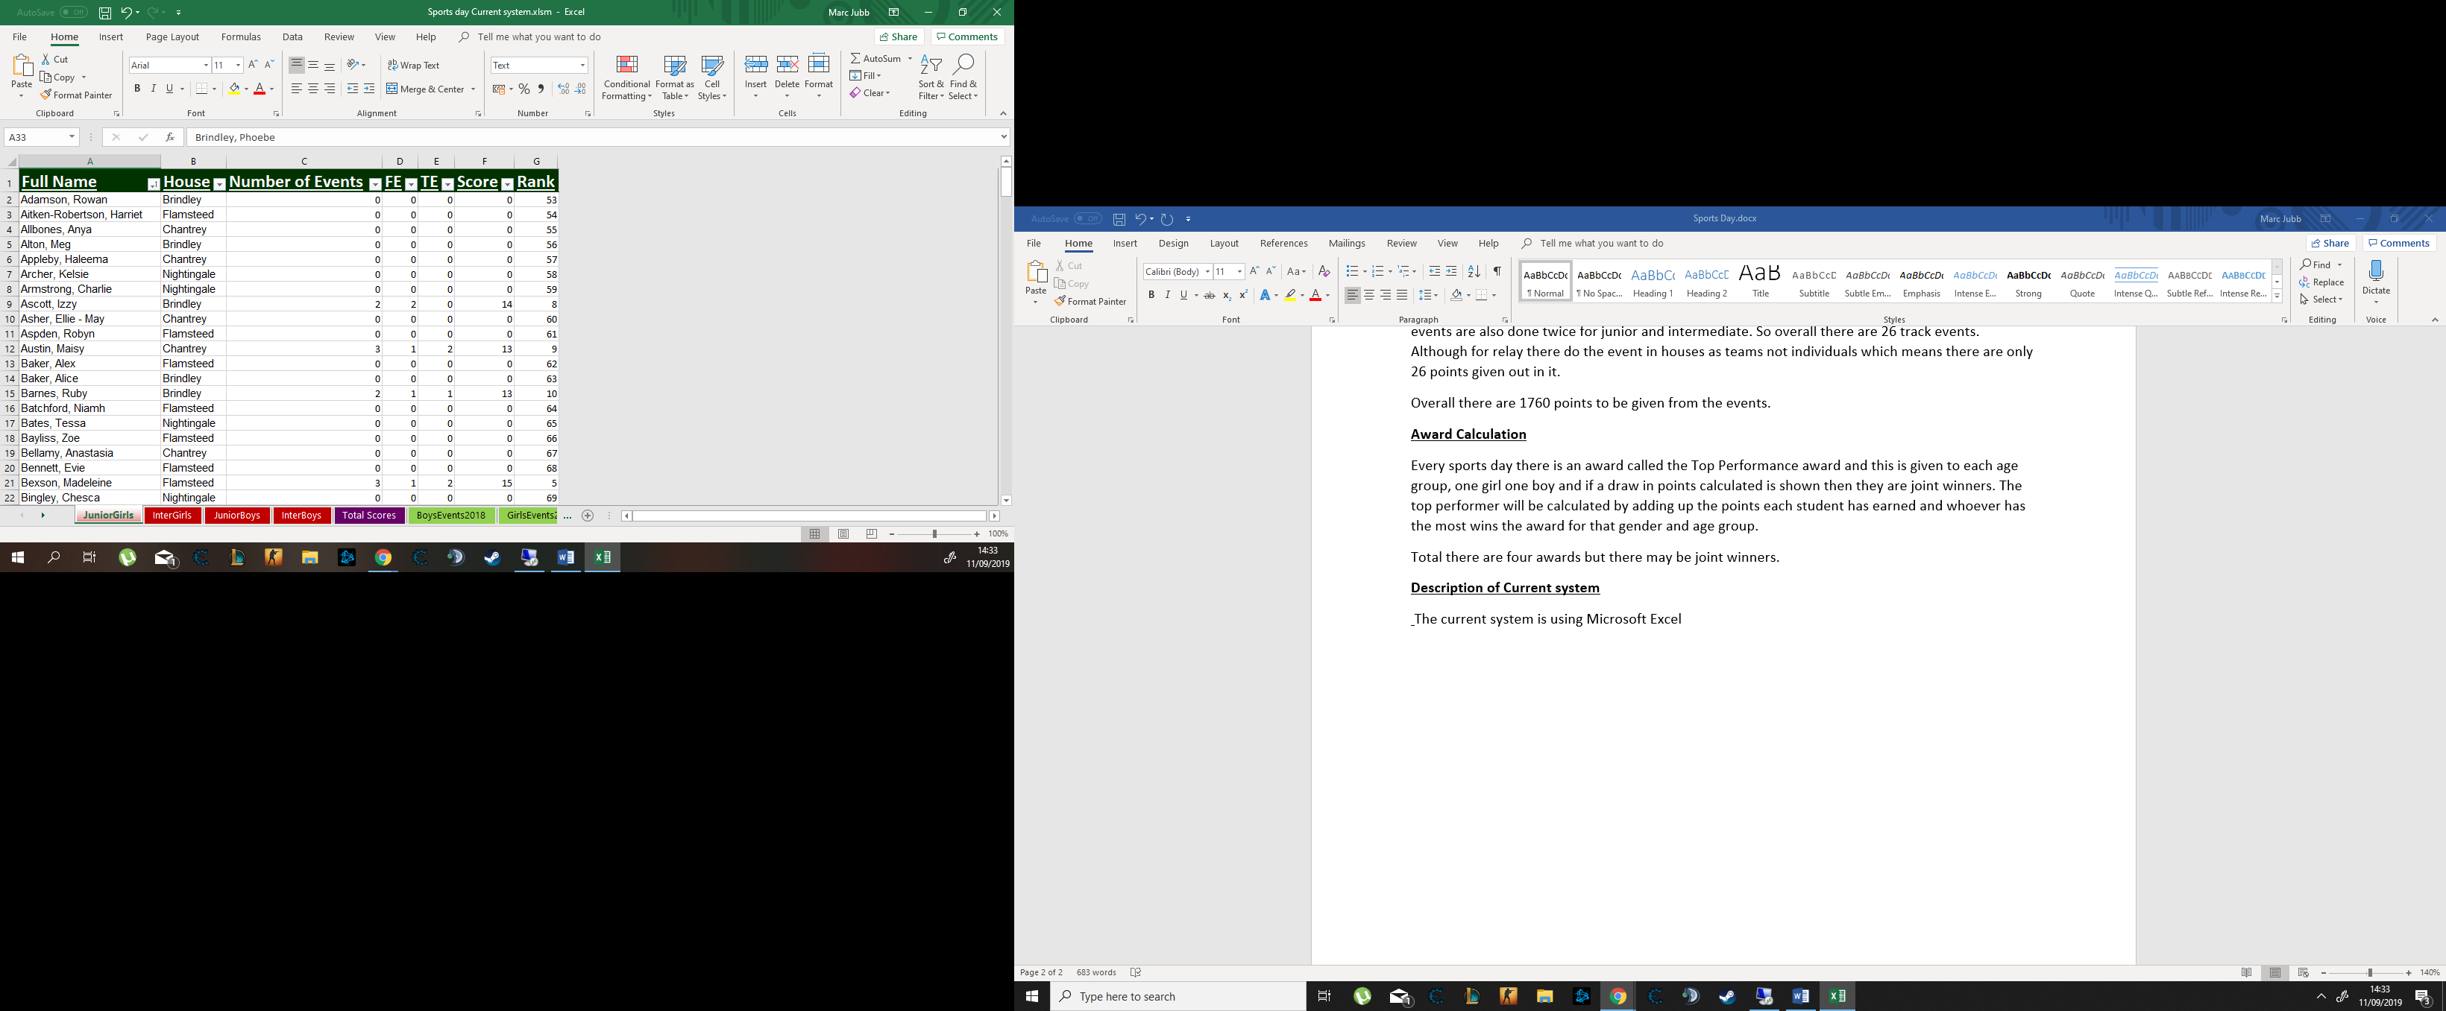The current system is currently using Microsoft Excel. There is a large dataset with all of the student’s names, house, number of events entered, number of number of track events taking part in, score gained from the events and their rank in comparison the rest of the students within their age group and gender. This dataset is split into junior girls, Intermediate girls, junior boys and intermediate boys.

In the current system, there is a tab for Boys events and a tab for Girls events. Within the tabs, there is a format of the event names with eight places underneath them and two columns to put names one for junior and one for intermediate. Also shown is the house the student entered is in with a colour-coded system. The input of data into the races done by manually write out the student’s name.

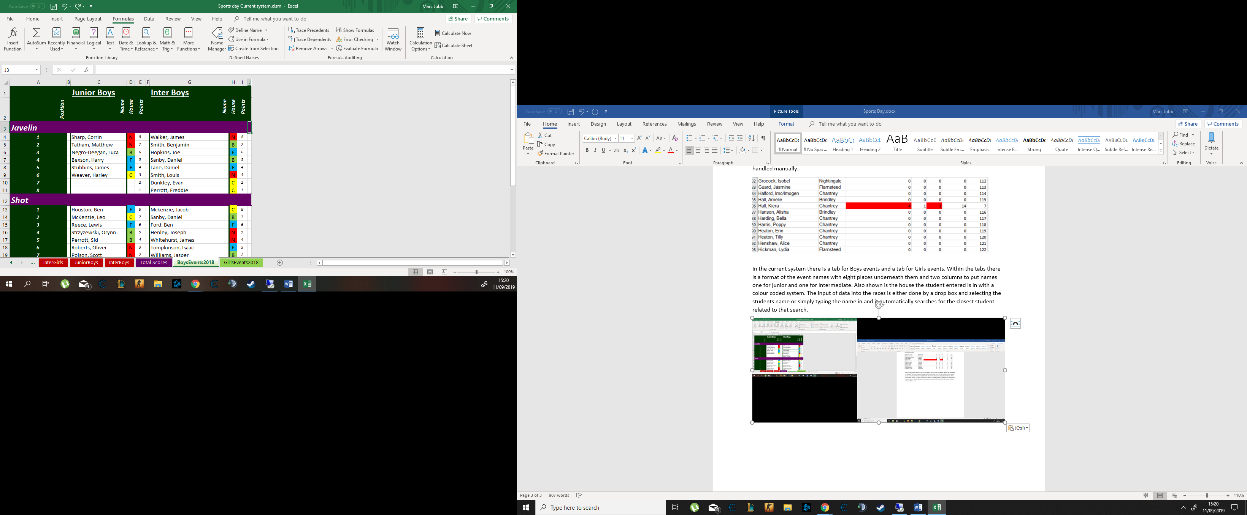On the total scores tab there are the four houses with their total score for each age group and gender which add up to make the houses total score. This score is compared to the other houses scores and the highest one is the winner of sports day. All of these calculations are done inefficiently as the user needs to do the maths manually.

## Breaking down issues of the current system

* All calculations done are manual. This cause’s human error to take a play into the inputs into the calculations meaning the results may not be valid.
* No secure login system. Therefore, anyone who wants to view the system can edit the whole database, which could cause cheating, or misuse of the system, thus the new system will have a login system with access rights given to specific users.
* No use of graphics to prevail the scores to the user in a visual, more user friendly way.
* No search system for events or students. This wastes the time of the day causing events to be delayed.
* Tough to add, edit or remove an event or a student without unnecessary destruction of the formatting/system.
* No use of reporting/exporting to a different format in order to print of a ticket to give the participant. This helps the participant remember that they have an event to get to and at which time.

## Limitations of the system

During my project I have experienced issues which may affect the outcome of the system.

# Design

## C:\Users\hs.mjubb\Downloads\High-level overview (5).pngHigh-level System View

## Data Structures

## Entity Relationship Diagram

## Data Dictionary

Here is the data dictionary for all the fields in the database above.

Table: **entStudents**

|  |  |  |
| --- | --- | --- |
| Field Name | Data Type | Description of Purpose |
| ID | Integer (AutoNumber) | Primary key |
| Firstname | String | Stores first name of student |
| Surname | String | Stores last name of student |
| Gender | Long Integer | Stores gender of student |
| YearGroup | Long Integer | Integer representing the students Yeargroup |
| AgeGroup | Long Integer | Integer representing the students AgeGroup |
| House | Long Integer | Integer representing the students House |

Table: **entEvents**

|  |  |  |
| --- | --- | --- |
| Field Name | Data Type | Description of Purpose |
| ID | Integer (AutoNumber) | Primary key |
| Event | String | Stores name of the event |
| AgeGroup | Long Integer | Integer representing the students AgeGroup |
| Gender | Long Integer | Integer representing |
| EventType | Long Integer | Integer representing the event’s type |

Table: **entUsers**

|  |  |  |
| --- | --- | --- |
| Field Name | Data Type | Description of Purpose |
| ID | Integer (AutoNumber) | Primary key |
| Username | String | Stores name of the user |
| Password | String | Stores passcode of the user |
| Accesslevel | Long Integer | Integer representing the Accesslevel |

Table: **entResult**

|  |  |  |
| --- | --- | --- |
| Field Name | Data Type | Description of Purpose |
| ID | Integer (AutoNumber) | Primary key |
| ParticipantID | String | Stores name of the event |
| FinalResult | Long Integer | Integer representing the students AgeGroup |
| Points | Long Integer | Integer representing the points the participant scored. |

Table: **entParticipants**

|  |  |  |
| --- | --- | --- |
| Field Name | Data Type | Description of Purpose |
| ID | Integer (AutoNumber) | Primary key |
| EventID | Long Integer | Stores Event’s ID of the participants entered event |
| StudentID | Long Integer | Stores the ID of the student whom is participating |

Table: **entGenders**

|  |  |  |
| --- | --- | --- |
| Field Name | Data Type | Description of Purpose |
| ID | Integer (AutoNumber) | Primary key |
| Gender | String | Stores the name of the gender |

Table: **entAgeGroups**

|  |  |  |
| --- | --- | --- |
| Field Name | Data Type | Description of Purpose |
| ID | Integer (AutoNumber) | Primary key |
| AgeGroup | String | Stores the name of the AgeGroup |

Table: **entEventType**

|  |  |  |
| --- | --- | --- |
| Field Name | Data Type | Description of Purpose |
| ID | Integer (AutoNumber) | Primary key |
| EventType | String | Stores the name of the EventType |

Table: **entAccesslevel**

|  |  |  |
| --- | --- | --- |
| Field Name | Data Type | Description of Purpose |
| ID | Integer (AutoNumber) | Primary key |
| Accesslevel | String | Stores the name of the Accesslevel |

Table: **entHouse**

|  |  |  |
| --- | --- | --- |
| Field Name | Data Type | Description of Purpose |
| ID | Integer (AutoNumber) | Primary key |
| House | String | Stores the name of the House |

## User interface design

Within the user interface my main objective is to make the project as easy as possible to use for all ages. This is going to be done with a common theme throughout the system as these has been proven to show a **professional looking system**.

In order to suit all of the user’s I have gone for a light blue faded background with a black font text. This suits the **dyslexic** and the **lesser sighted users**.

### Login System

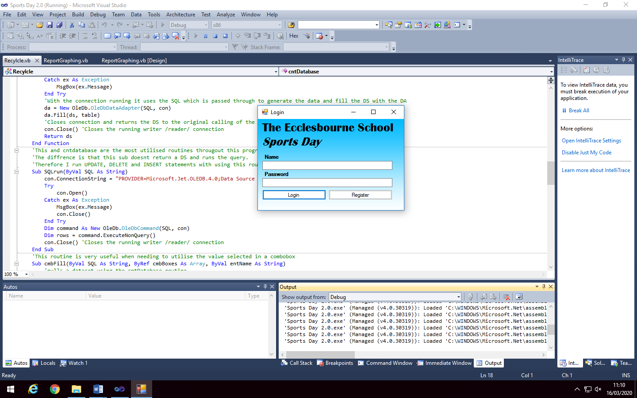

Titled **login system** displaying to the user what system they have loaded and giving the user the necessary information for their login

**Minimalistic approach** in order for the end user to understand where they need to input information to proceed.

The password will be displayed in “*” format in order to protect the user from **shouldering social engineering**.

### Main Menu: Administrator Access

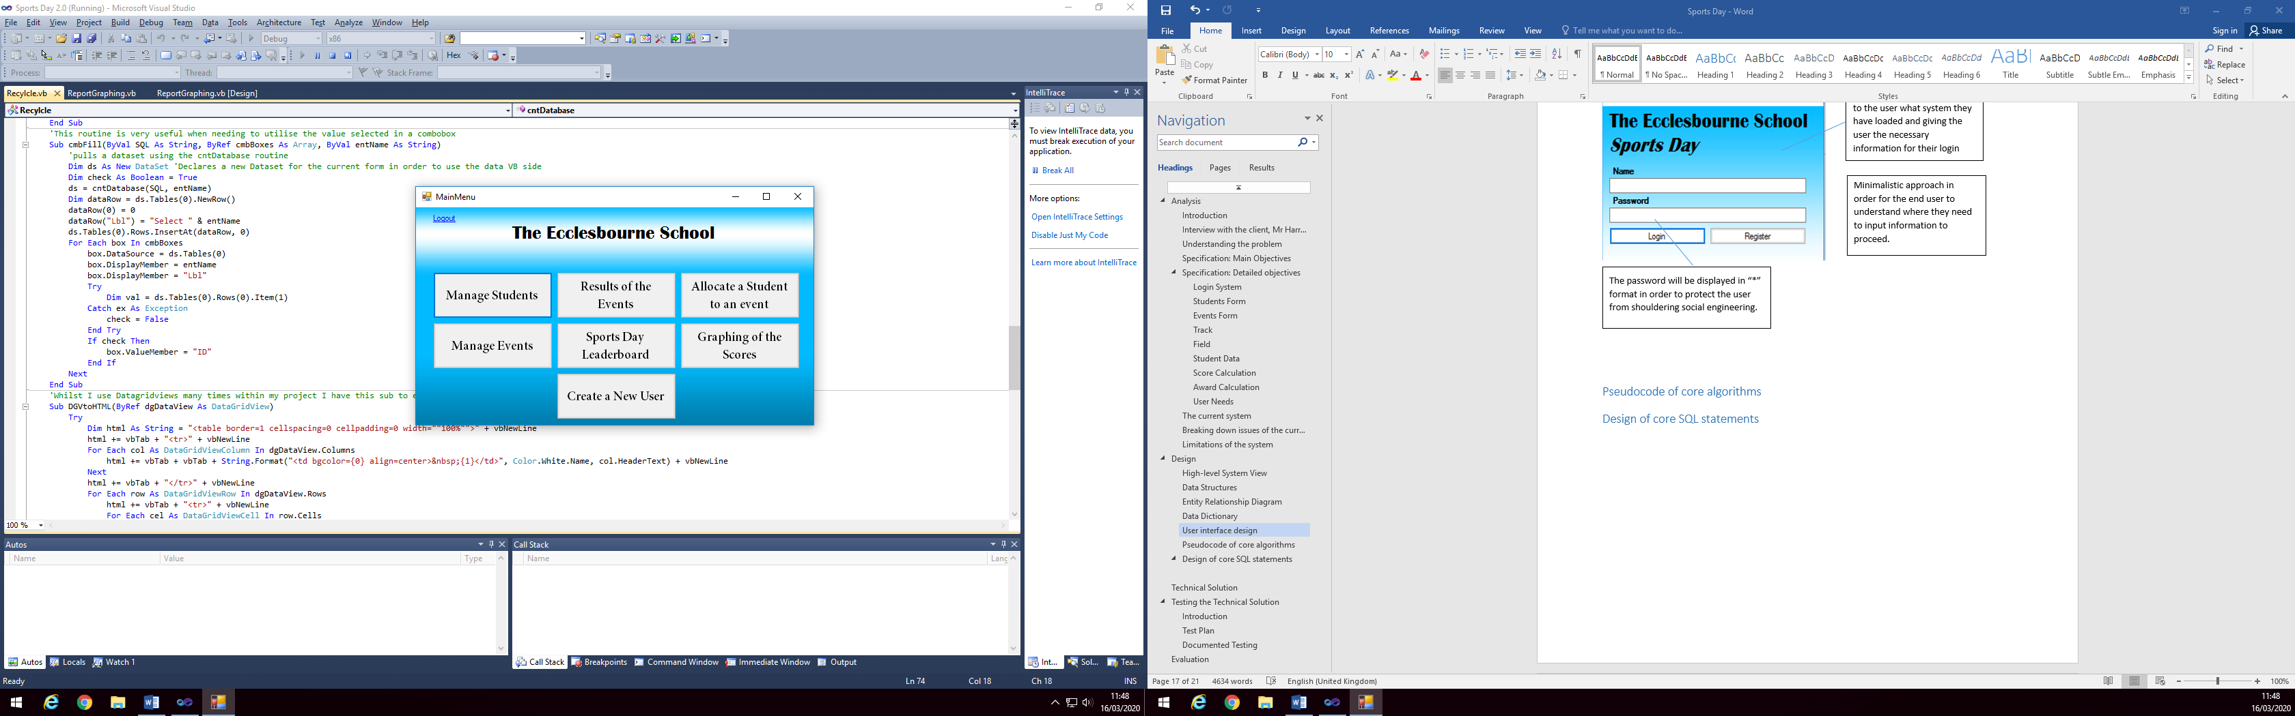

This is the **hub** of the form. The design is to give the user a wide display of options to choose. These choices will lead the user to areas they can visit for more information.

This form is specifically made for the admin **access level**. This includes all options displayed as they have the rights for all other forms.

Throughout the forms I make use of a **navigation system** using logout, back and buttons throughout. These are located at the top corners of each form.

Within my **background design** I have changed the fade in order to suit the main menu. This differs from the login system as the strip of white is enhancing the title of the Ecclesbourne school.

Ecclesbourne

### Main Menu: Student Access

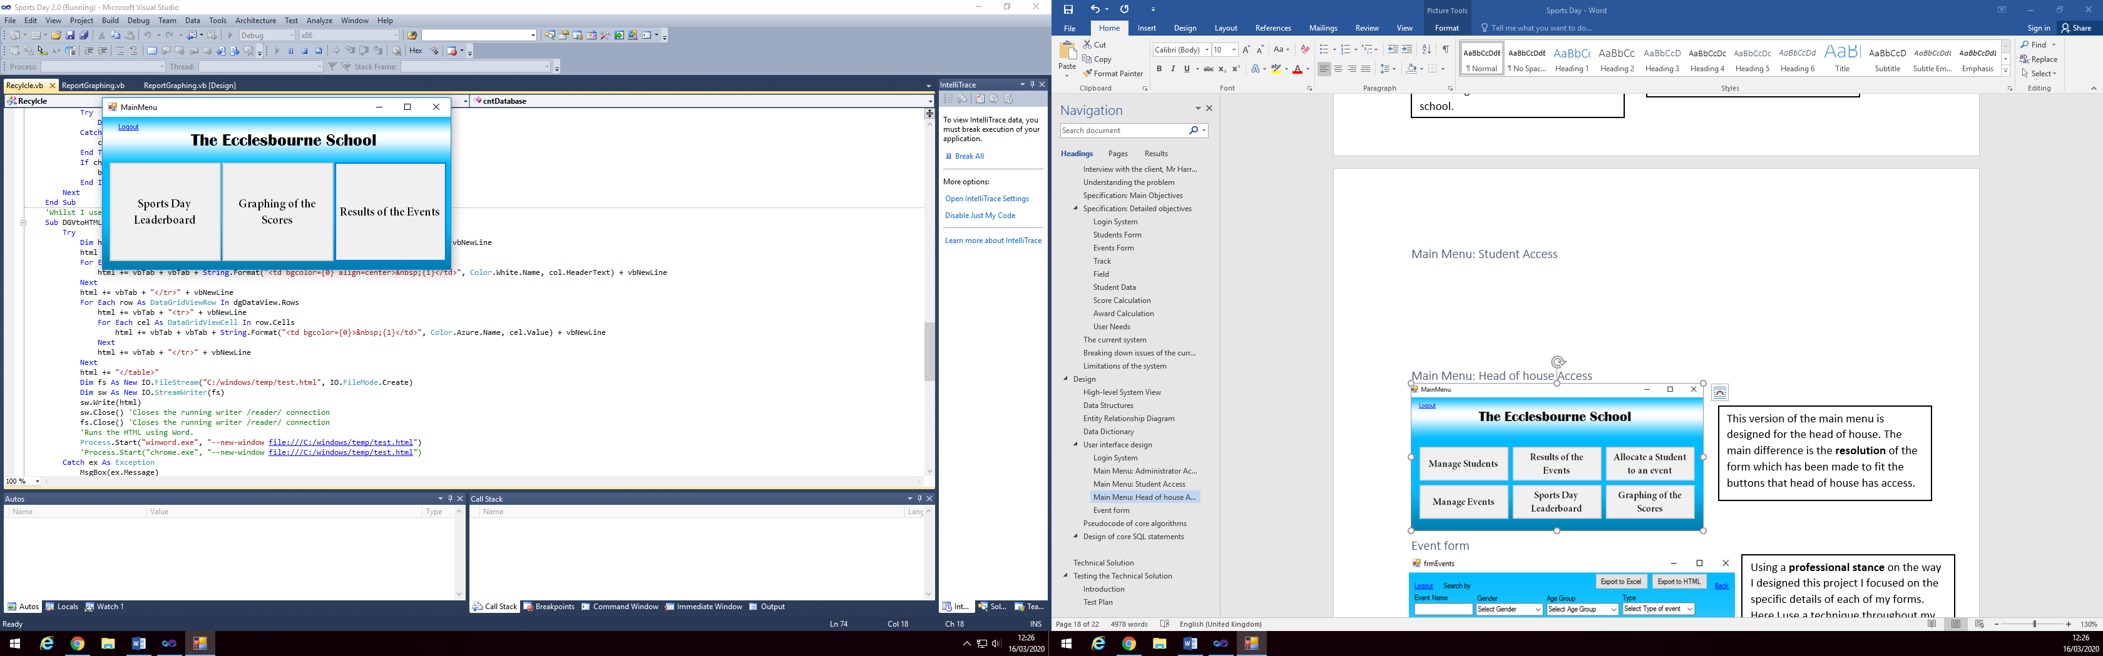

This version of the main menu is designed for the **students**. The main difference is the **resolution** and the **buttons size** of the form which has been made to fit the buttons that student has access to.

### Main Menu: Head of house Access

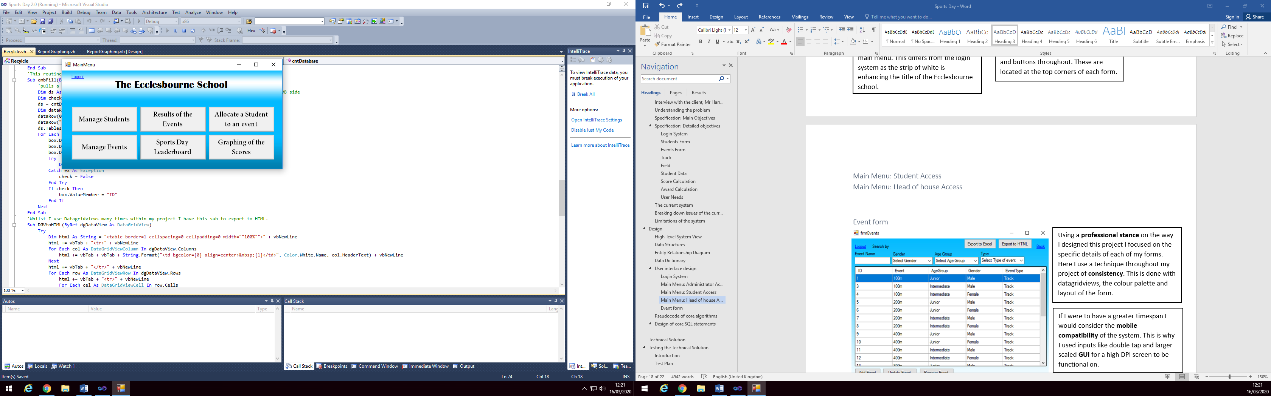

This version of the main menu is designed for the **head of house**. The main difference is the **resolution** of the form which has been made to fit the buttons that head of house has access to.

### Event form

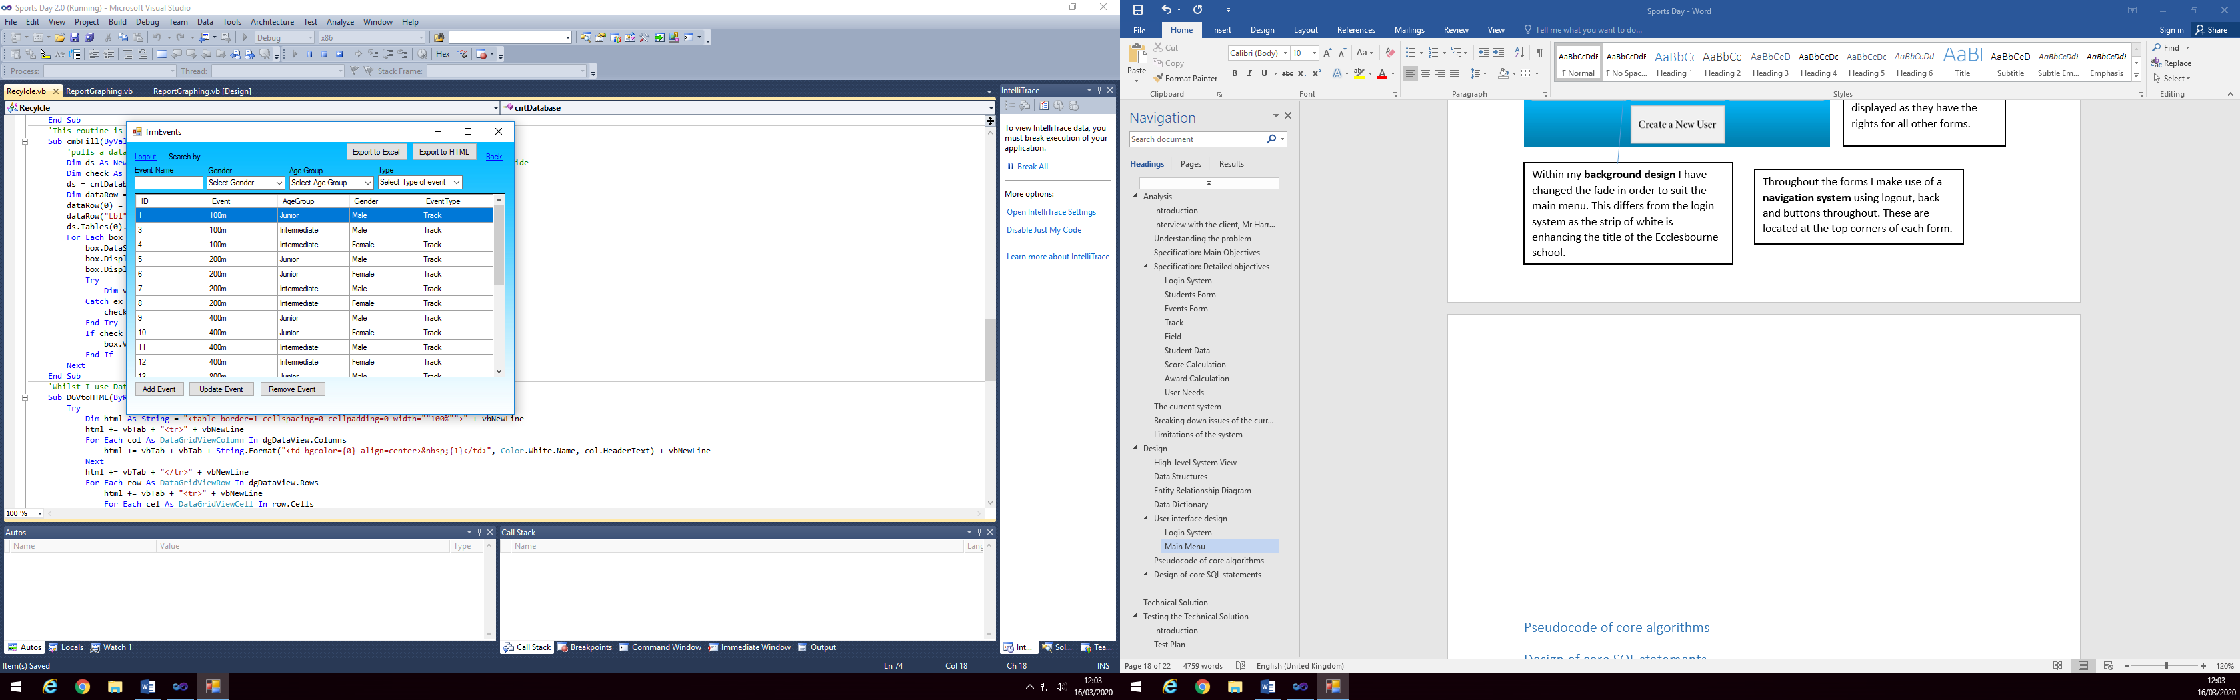

Using a **professional stance** on the way I designed this project I focused on the specific details of each of my forms. Here I use a technique throughout my project of **consistency**. This is done with datagridviews, the colour palette and layout of the form.

If I were to have a greater timespan I would consider the **mobile compatibility** of the system. This is why I used inputs like double tap and larger scaled **GUI** for a high DPI screen to be functional on.

The search system is split up into different options form **user functionality**. For example, if you would want to search only by gender, you are able to by selecting a gender to search by.

The main design of this form is to show the events and their information. Also to be able to edit, add or remove an event through the system with ease.

Also in order to print reports of the events taking place we have two buttons which **export** to Excel and HTML.

### Add Event form

This form is designed for the access level two or above. The main interest of this form is to **input data** into the different sections and then press a button to add the event.

Therefore, I have the guidance at the top of the form indicating the user on how to use it.

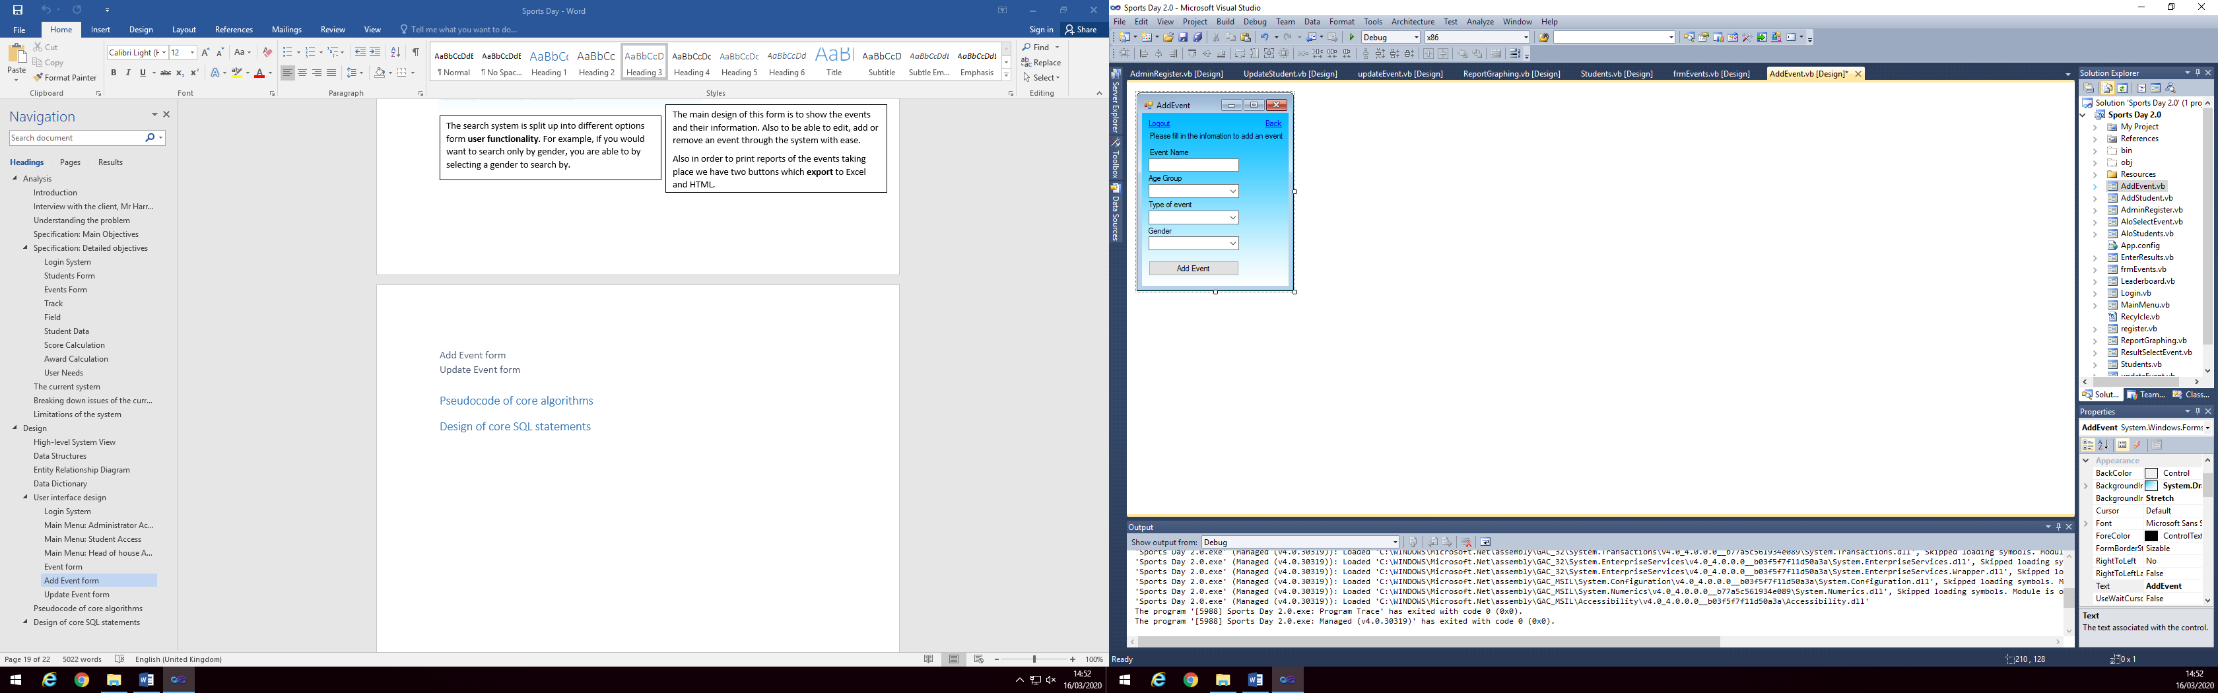

Whilst designing these functionality forms, we do the upmost to ensure the end user cannot input with human error, this is done with combo boxes where the options are mandatory. If the boxes are not filled, then a message will show tell them to fill all details.

### Update Event form

Like the add event form, the design includes the necessary textboxes for updating an event. To ensure the **efficiency** of the program, the data of the selected event will be shown in the editable boxes.

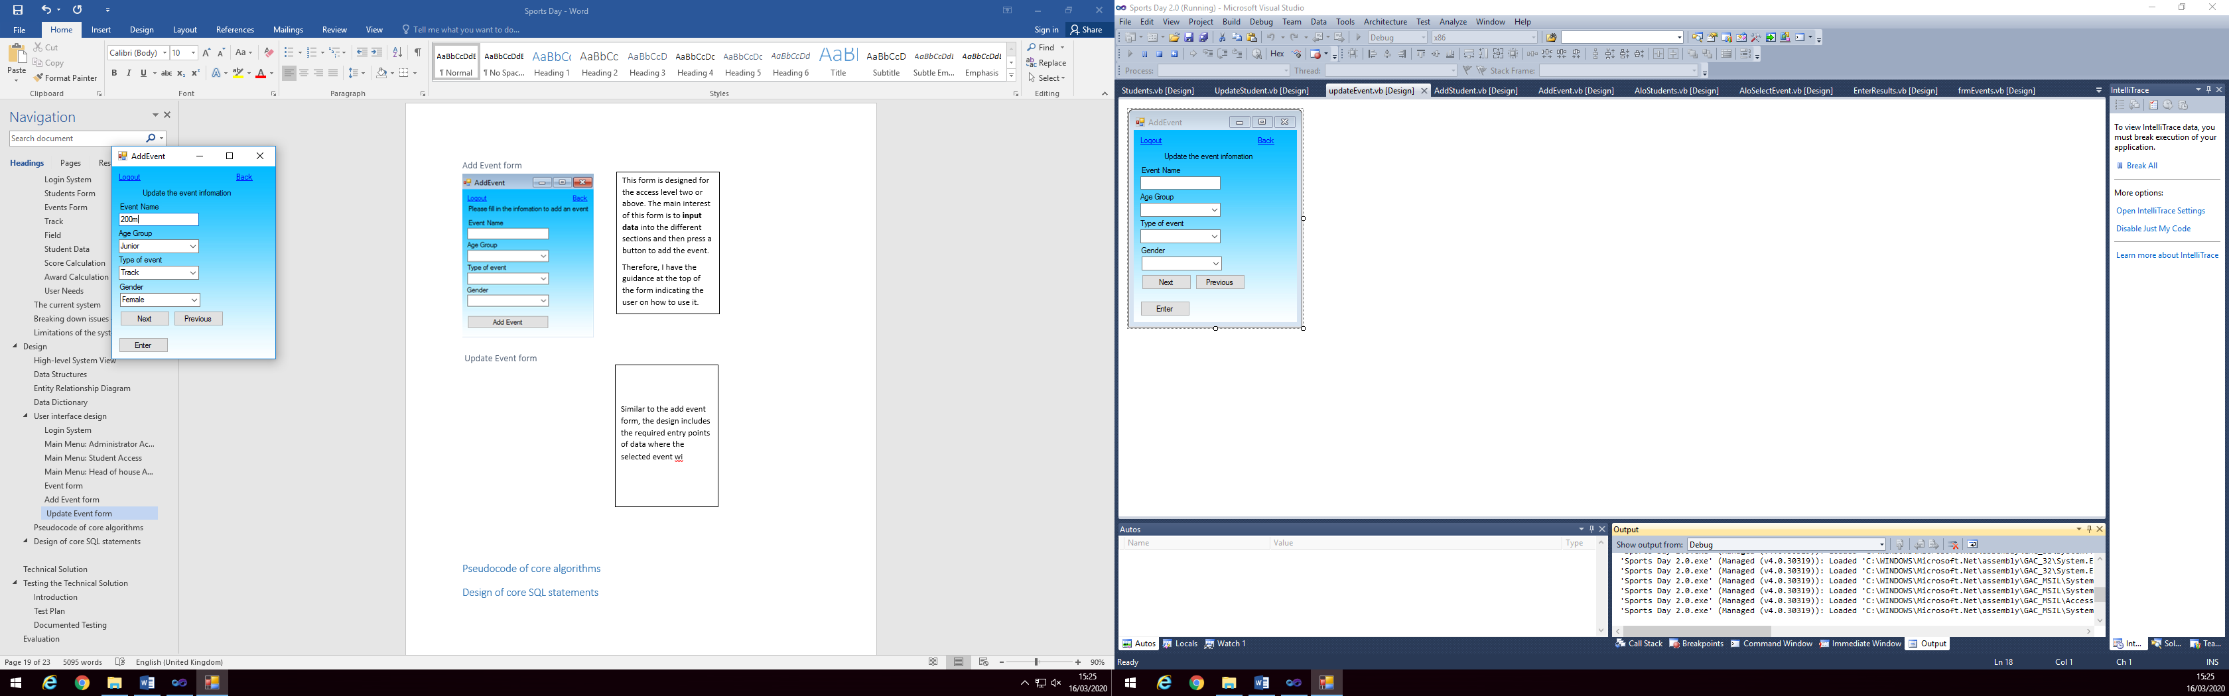

To prevail **ease of use**, I have designed the formed to have two buttons which selects the next event in the list of events, or the pervious event. This helps the client not need to go back and forth to update an event

### Add and Update Student

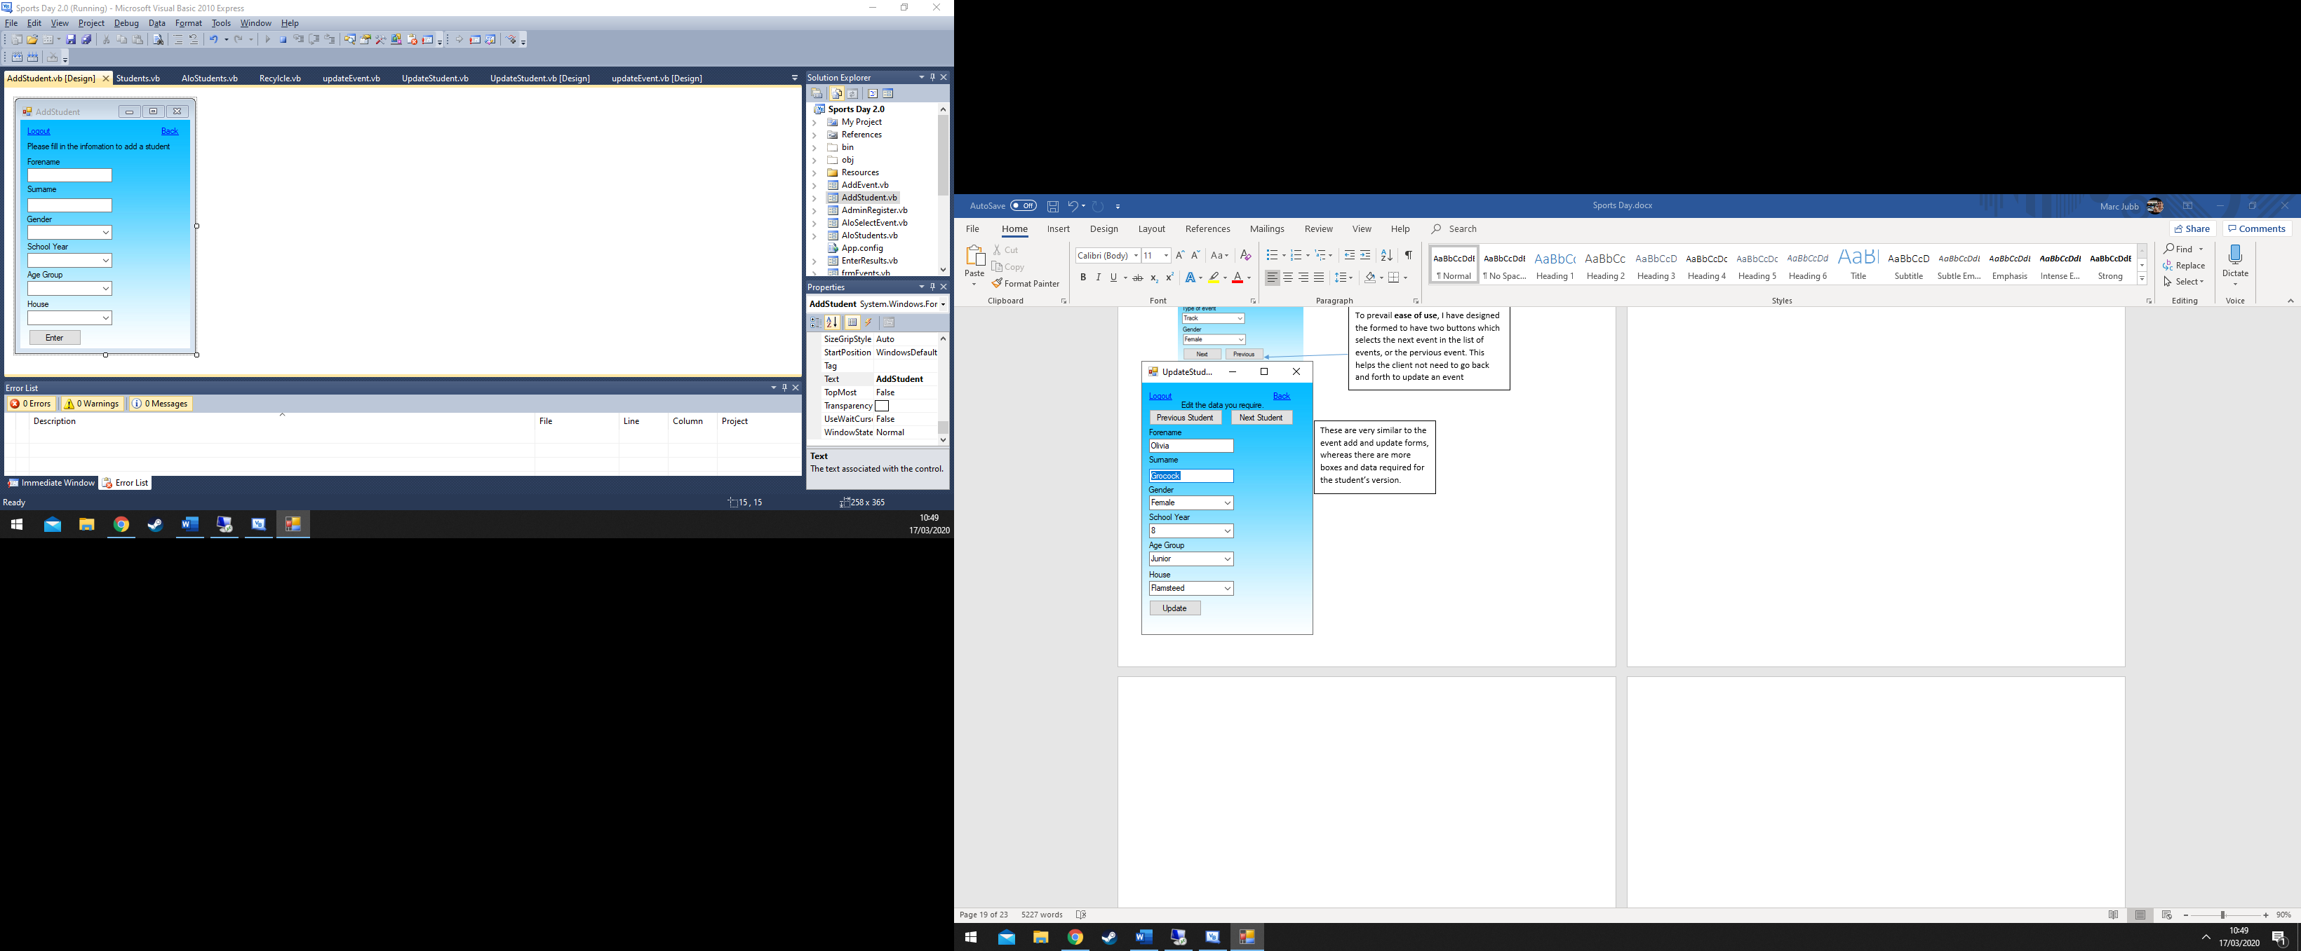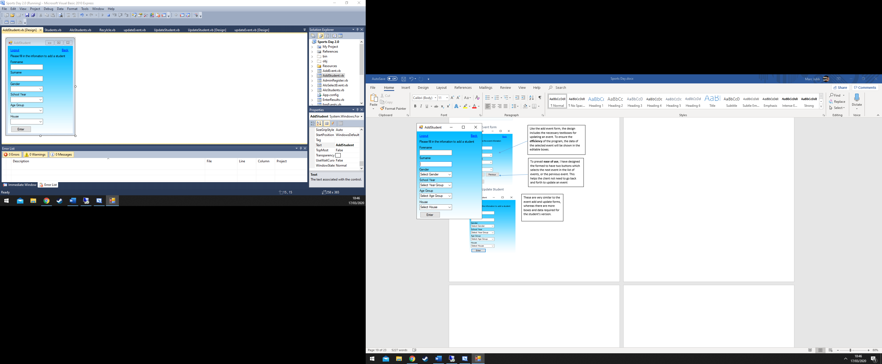

These are very similar to the event add and update forms, whereas there are more boxes and data required for the student’s version.

### Student Form

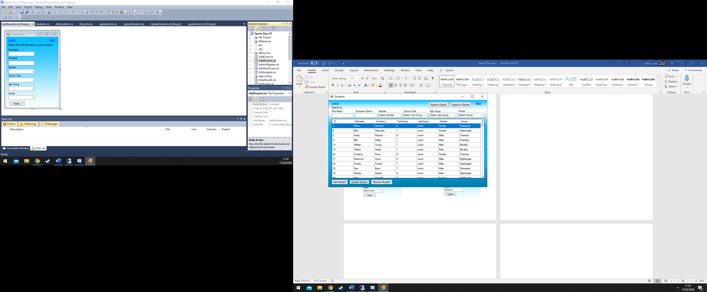

Maintaining the **colour scheme** throughout I have the faded white underneath the search system labels in order to really prove the design of the system to the end user giving it a clean, welcoming look.

The main functionality of this form is to show the students data, therefore in the design process we decided to give the **DGV** a larger portion of the form.

### Results Enter

## Pseudocode of core algorithms

## Design of core SQL statements

# Technical Solution

# Testing the Technical Solution

## Introduction

Throughout my testing, I will be using a standard testing table template to illustrate my results.

|  |  |  |  |  |  |
| --- | --- | --- | --- | --- | --- |
| Test purpose: The reason the test is being conducted. | | | | | |
| Test No. | **Test Type** | **Test Data** | **Expected Result** | **Actual Result** | **Pass?** |
| e.g. 1 | N, B, or E, where:  N = normal  B = boundary  E = erroneous | The data being inputted to the system. | The expected returned result from the system | The actual returned result from the system. | **✔**  or  **X** |

The evidence of each test will be presented in the ‘Documented Testing’ chapter.

During the testing, I will be ensuring that the technical solution functions fully without error. This will be done with iterative testing of functions and key parts of the code, which if a failure occurs I will go over, fix the issue and retest the function until no faults occur. Upon finalisation of the project, I will have the ability to present the complete technical solution with tested evidence showing that it meets the requirements of end user.

## Test Plan

The following plan will be used to detail the tests that will be required to run and pass in order to prove that the technical solution meets the specification.

|  |  |  |  |  |
| --- | --- | --- | --- | --- |
| Test No. | Test Type | Test Purpose | Test Data | Expected Result |
| 1 | Normal | Test that admin login functions correctly with a valid input of initials. | Jason Gormo | Proceeds to the main menu with administrative rights. |
| 2 | Normal | Test that student login functions correctly with a valid input of initials. |  |  |
| 3 |  |  |  |  |

## Documented Testing

Using the test plan each test will be conducted, with the result being documented here.

|  |  |  |  |  |  |
| --- | --- | --- | --- | --- | --- |
| Test purpose: Test that student login functions correctly with a valid input of initials. Also tests AI character classification performance. | | | | | |
| No. | **Type** | **Test Data** | **Expected Result** | **Actual Result** | **Pass?** |
| 1 | Normal | I F | “Are you Isabella Forsyth?” | “Are you Isabella Forsyth?” | **✔** |

# Evaluation